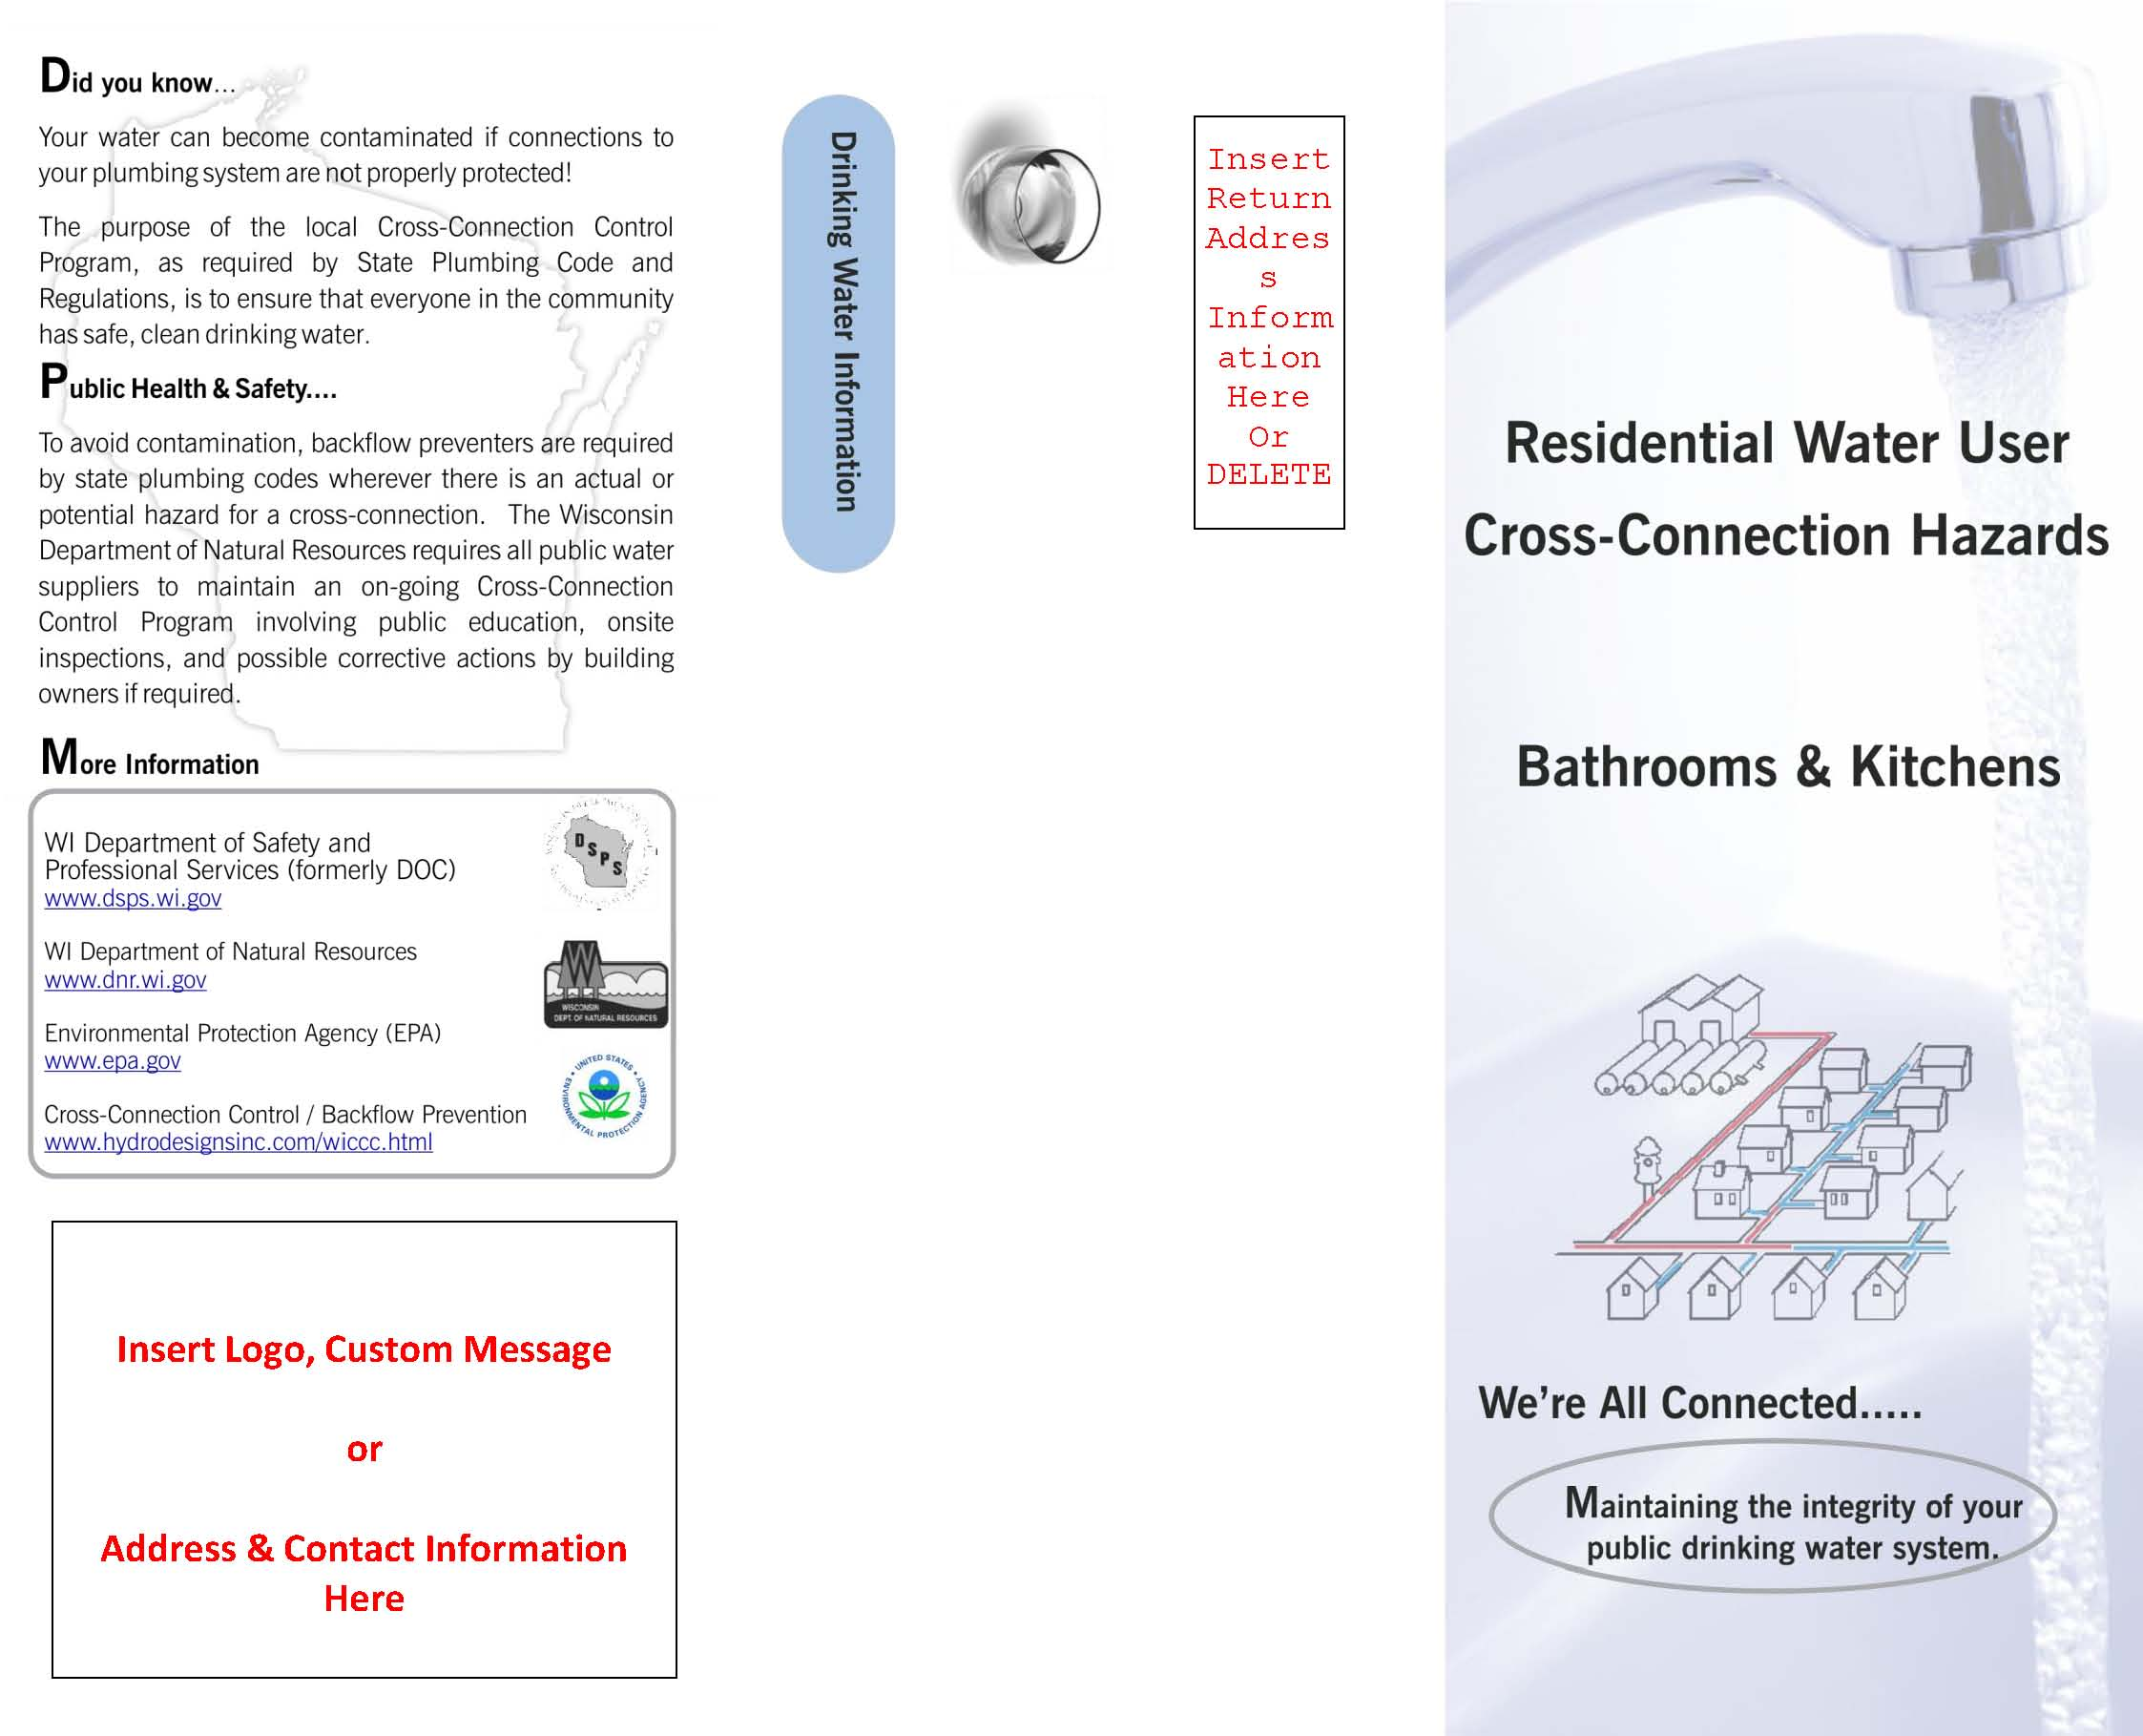

**For more information:**

Mike Burg, Utility Operator  
City of Bayfield  
125 S. 1st Street   
Bayfield, WI 54814  
  
P:(715) 779-5712  
F: (715) 779-5094

